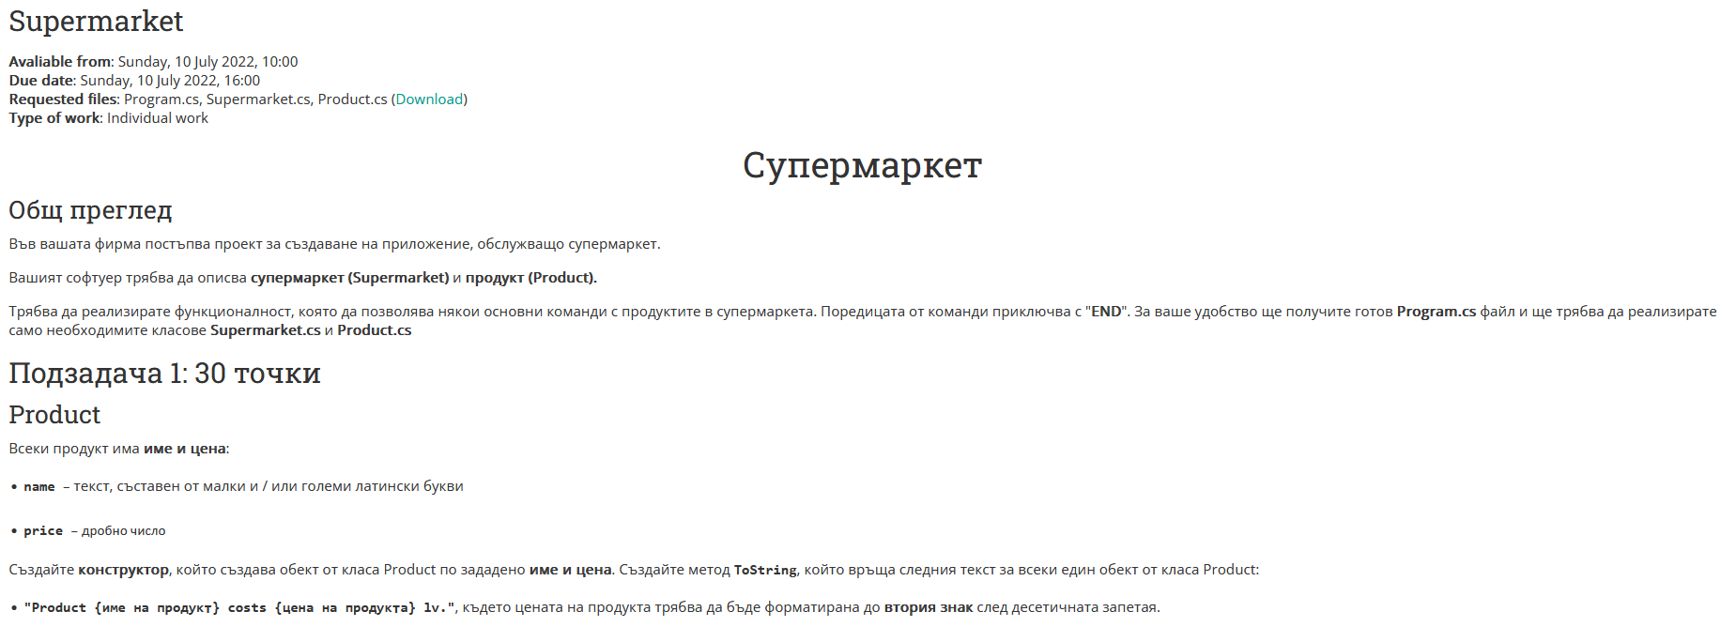

|  |
| --- |
| **Product.cs** |
| private string name;  private double price;  public Product(string name, double price)  {  //TODO: Добавете вашия код тук …  }  public string Name  {  //TODO: Добавете вашия код тук …  }  public double Price  {  //TODO: Добавете вашия код тук …  }  public override string ToString()  {  //TODO: Добавете вашия код тук …  } |

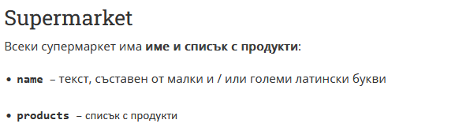

|  |
| --- |
| **Supermarket.cs** |
| private string name;  private List<Product> products;  public Supermarket (string name)  {  //TODO: Добавете вашия код тук …  }  public string Name  {  //TODO: Добавете вашия код тук …  }  public List<Product> Products  {  //TODO: Добавете вашия код тук …  }  public void AddProduct(string name, double price)  {  //TODO: Добавете вашия код тук …  }  public double AveragePriceInRange(double start, double end)  {  //TODO: Добавете вашия код тук …  }  public List<string> FilterProductsByPrice(double price)  {  //TODO: Добавете вашия код тук …  }  public List<Product> SortAscendingByName()  {  //TODO: Добавете вашия код тук …  }  public List<Product> SortDescendingByPrice()  {  //TODO: Добавете вашия код тук …  }  public bool CheckProductIsInSupermarket(string name)  {  //TODO: Добавете вашия код тук …  }  public string[] ProvideInformationAboutAllProducts()  {  //TODO: Добавете вашия код тук …  } |

### Примери

|  |  |
| --- | --- |
| **Вход** | **Изход** |
| Add bread 4.50  Add milk 2.30  Add soap 3.40  Print  END | Added product bread.  Added product milk.  Added product soap.  Product bread costs 4.50 lv.  Product milk costs 2.30 lv.  Product soap costs 3.40 lv. |
| Add bread 4.50  Add soap 2.30  Add cheese 3.40  Add oil 3.50  Add orange 4.90  Add milk 3.40  Print  SortByName  Print  SortByPrice  Print  CheckProduct bread  CheckProduct carrot  AveragePrice 2.30 4.90  FilterProducts 3.60  END | Added product bread.  Added product soap.  Added product cheese.  Added product oil.  Added product orange.  Added product milk.  Product bread costs 4.50 lv.  Product soap costs 2.30 lv.  Product cheese costs 3.40 lv.  Product oil costs 3.50 lv.  Product orange costs 4.90 lv.  Product milk costs 3.40 lv.  First product is: bread  Product bread costs 4.50 lv.  Product cheese costs 3.40 lv.  Product milk costs 3.40 lv.  Product oil costs 3.50 lv.  Product orange costs 4.90 lv.  Product soap costs 2.30 lv.  The cheapest product is: soap  Product orange costs 4.90 lv.  Product bread costs 4.50 lv.  Product oil costs 3.50 lv.  Product cheese costs 3.40 lv.  Product milk costs 3.40 lv.  Product soap costs 2.30 lv.  Product bread is available.  Product carrot is not available.  Average price: 3.67  Filtered products: oil, cheese, milk, soap |

Картина, която съдържа маса

Описанието е генерирано автоматично

Program.cs

using System;

using System.Collections.Generic;

namespace Program

{

public class Program

{

static Supermarket supermarket = new Supermarket("Supermarket1");

static void Main(string[] args)

{

string line;

while ("END" != (line = Console.ReadLine()))

{

string[] cmdArgs = line.Split(' ');

switch (cmdArgs[0])

{

case "Add":

AddProduct(cmdArgs[1], double.Parse(cmdArgs[2]));

break;

case "AveragePrice":

AveragePriceInRange(double.Parse(cmdArgs[1]), double.Parse(cmdArgs[2]));

break;

case "FilterProducts":

FilterProductsByPrice(double.Parse(cmdArgs[1]));

break;

case "SortByName":

SortAscendingByName();

break;

case "SortByPrice":

SortDescendingByPrice();

break;

case "CheckProduct":

CheckProductIsInSupermarket(cmdArgs[1]);

break;

case "Print":

ProvideInformationAboutAllProducts();

break;

}

}

}

private static void ProvideInformationAboutAllProducts()

{

string[] info = supermarket.ProvideInformationAboutAllProducts();

foreach (string item in info)

{

Console.WriteLine(item);

}

}

private static void CheckProductIsInSupermarket(string name)

{

if (supermarket.CheckProductIsInSupermarket(name))

{

Console.WriteLine($"Product {name} is available.");

}

else

{

Console.WriteLine($"Product {name} is not available.");

}

}

private static void SortDescendingByPrice()

{

supermarket.SortDescendingByPrice();

Console.WriteLine("The cheapest product is: " + supermarket.Products[supermarket.Products.Count - 1].Name);

}

private static void SortAscendingByName()

{

supermarket.SortAscendingByName();

Console.WriteLine("First product is: " + supermarket.Products[0].Name);

}

private static void FilterProductsByPrice(double grade)

{

List<string> leftStudents = supermarket.FilterProductsByPrice(grade);

Console.WriteLine("Filtered products: " + string.Join(", ", leftStudents));

}

private static void AveragePriceInRange(double start, double end)

{

double averageGrade = supermarket.AveragePriceInRange(start, end);

Console.WriteLine($"Average price: {averageGrade:f2}");

}

private static void AddProduct(string name, double price)

{

supermarket.AddProduct(name, price);

Console.WriteLine($"Added product {name}.");

}

}

}